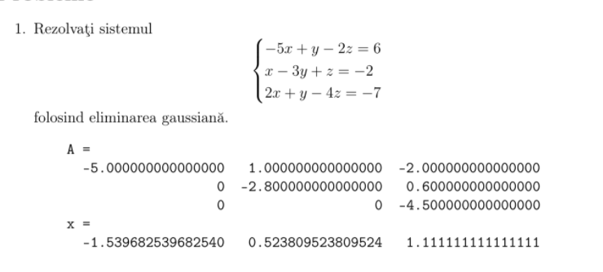

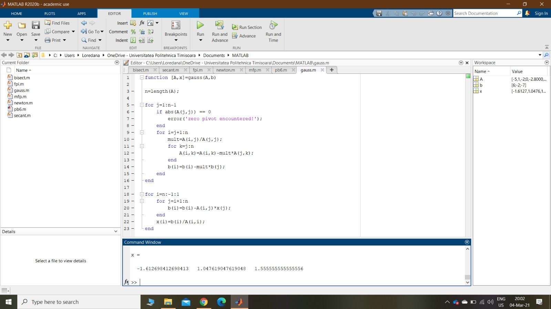

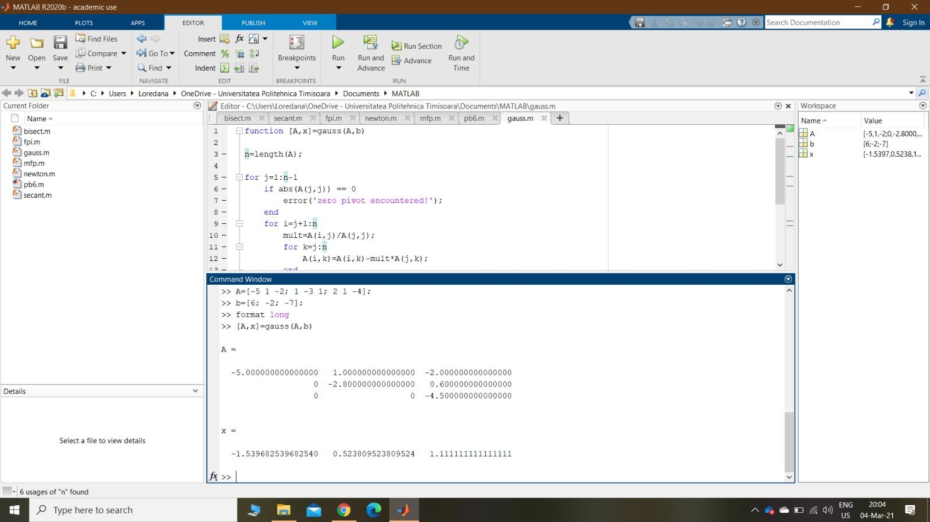

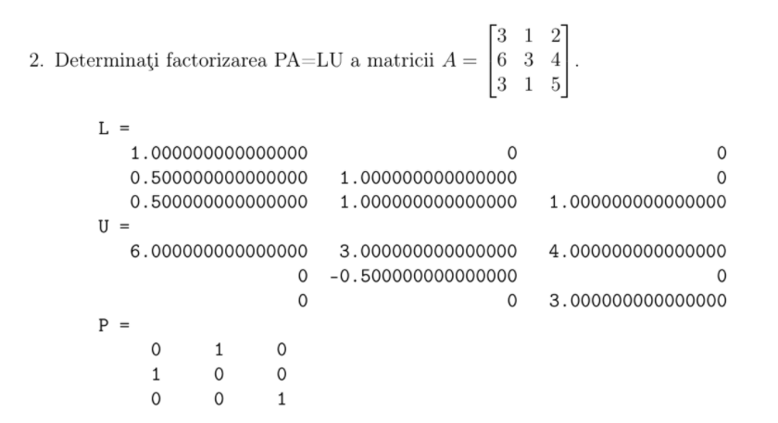

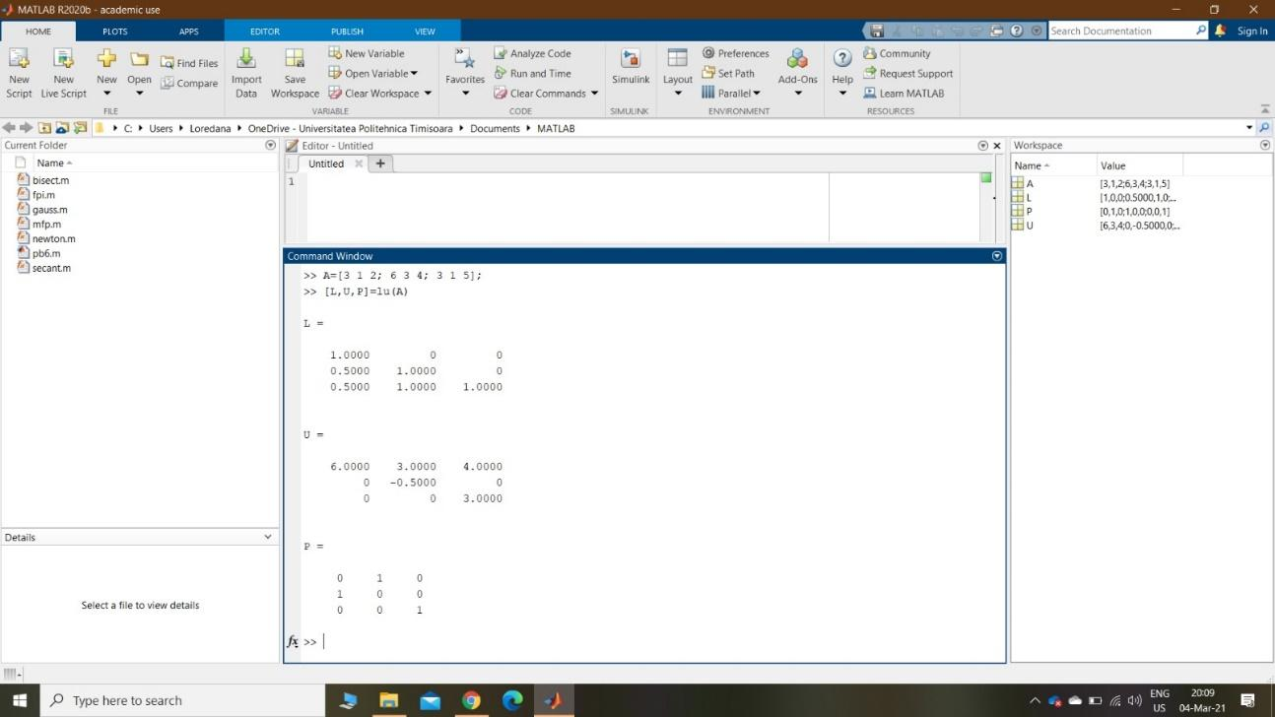

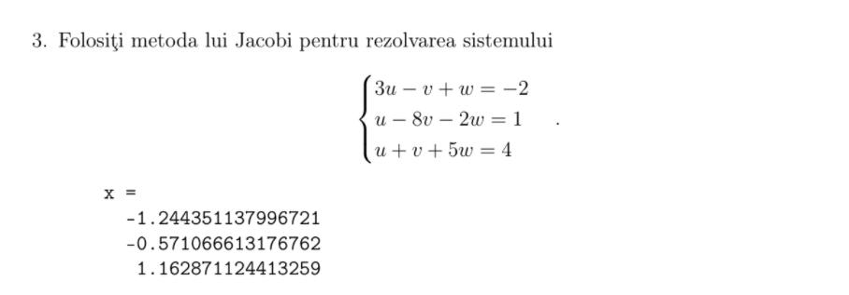

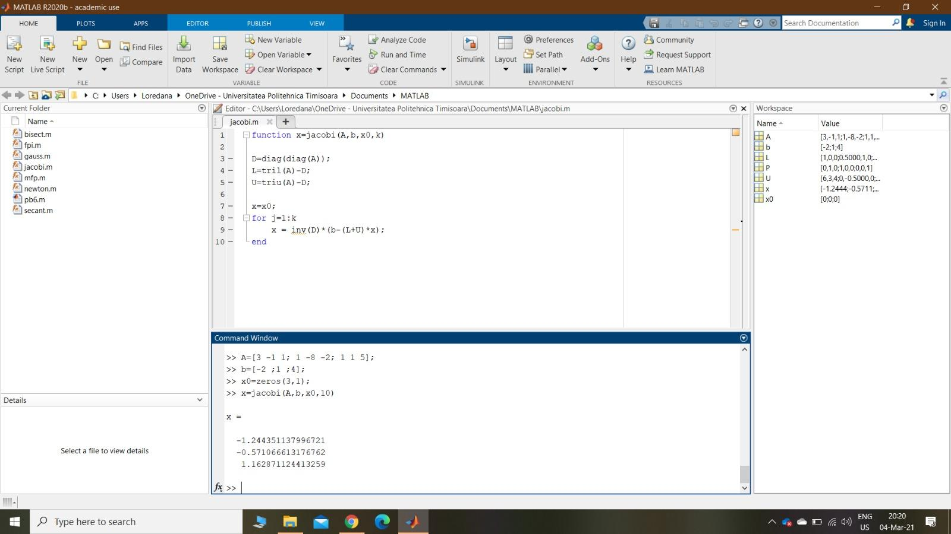

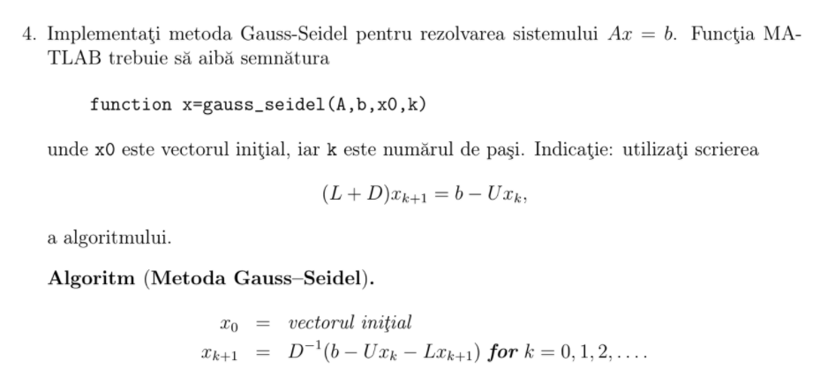

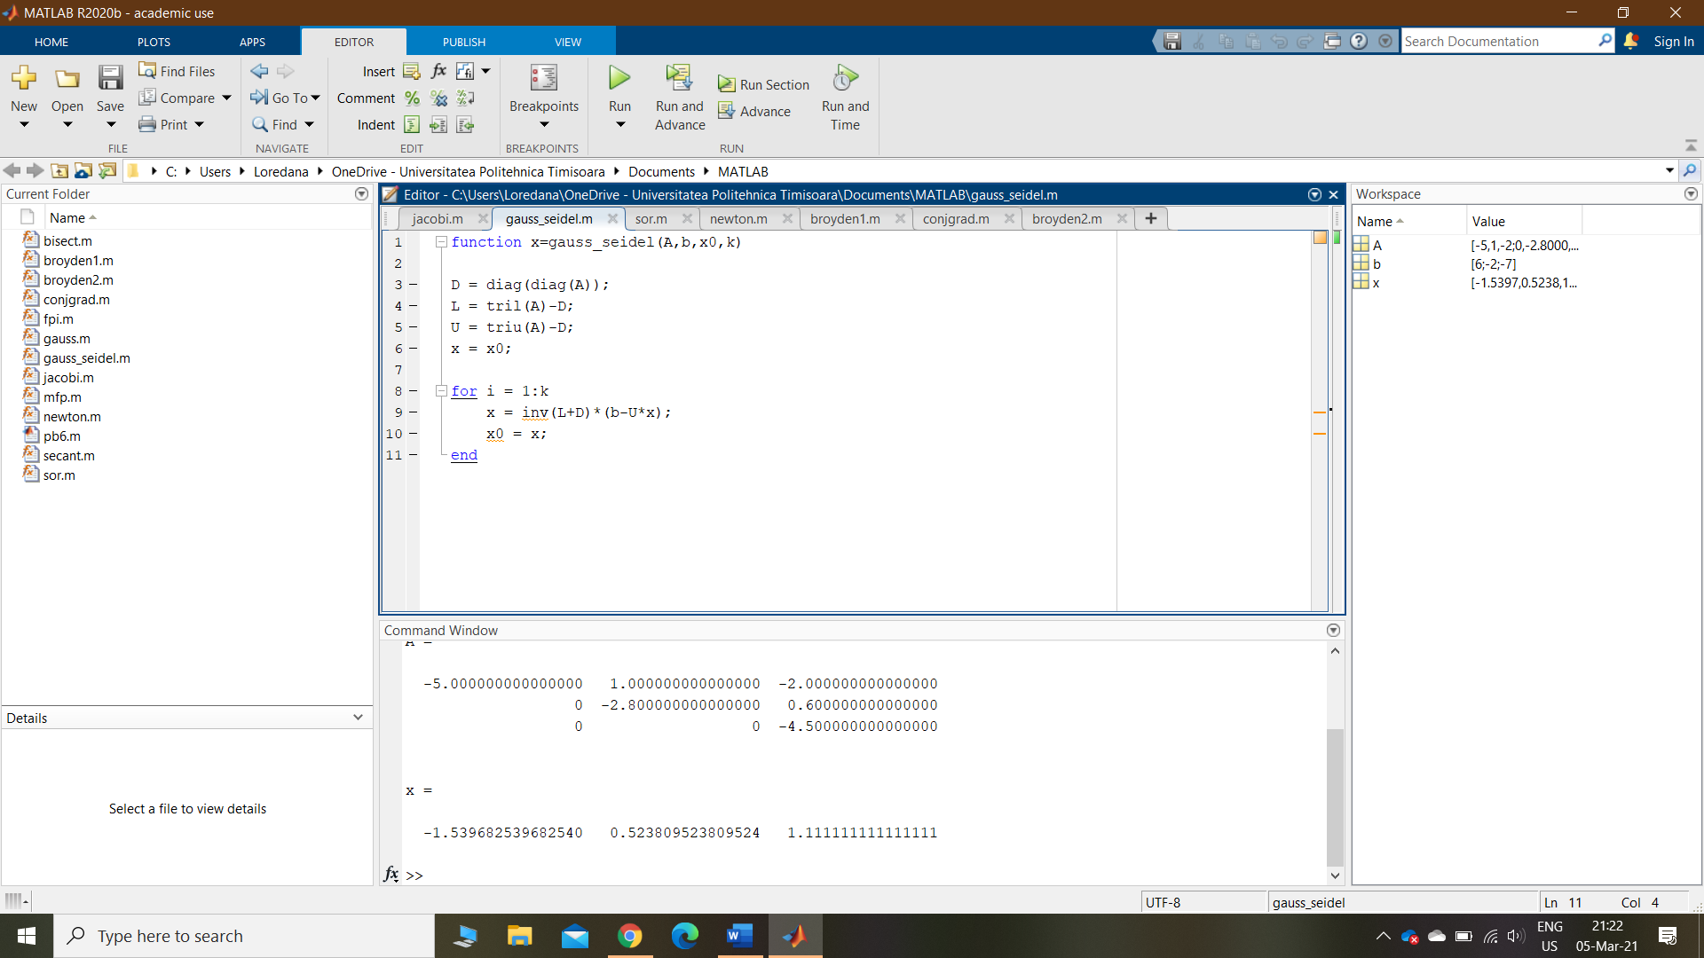

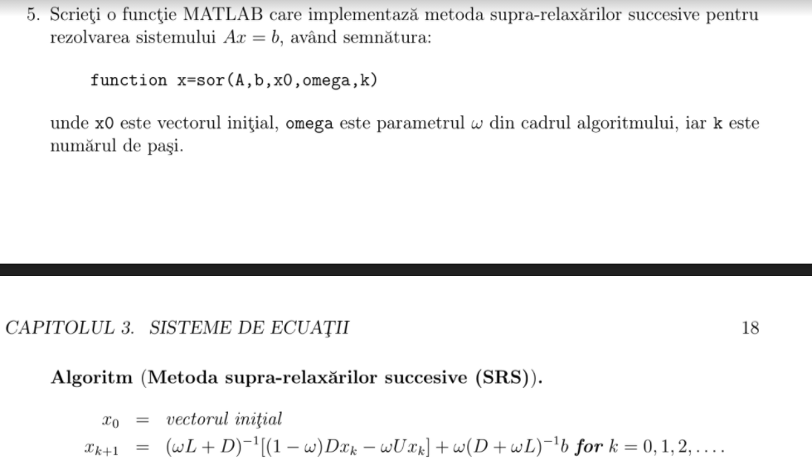

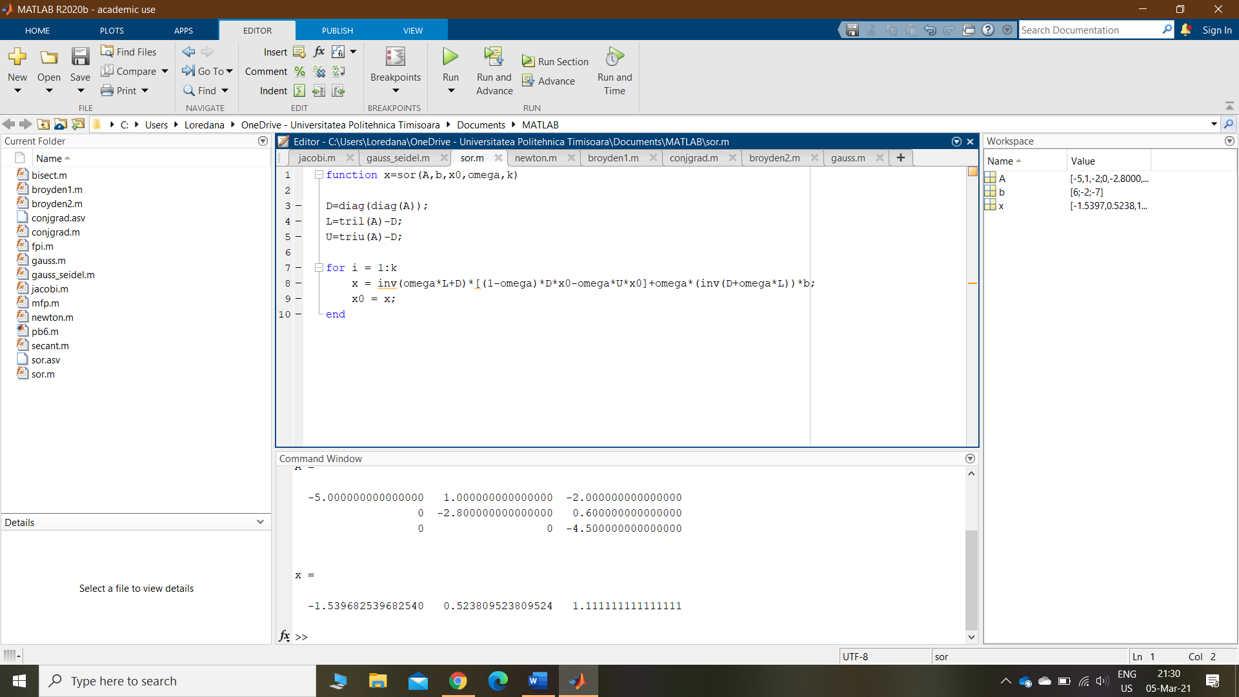

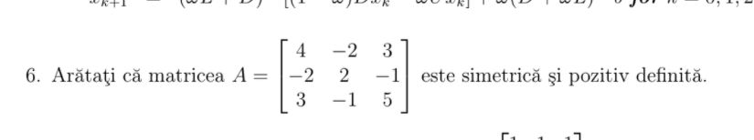

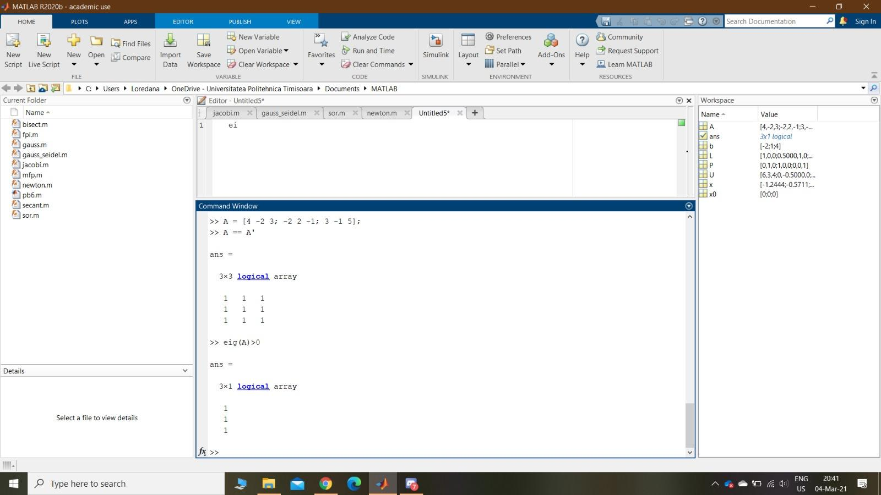

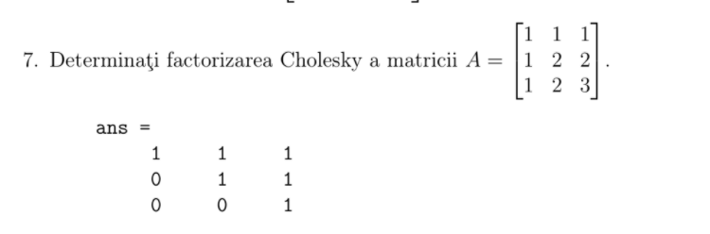

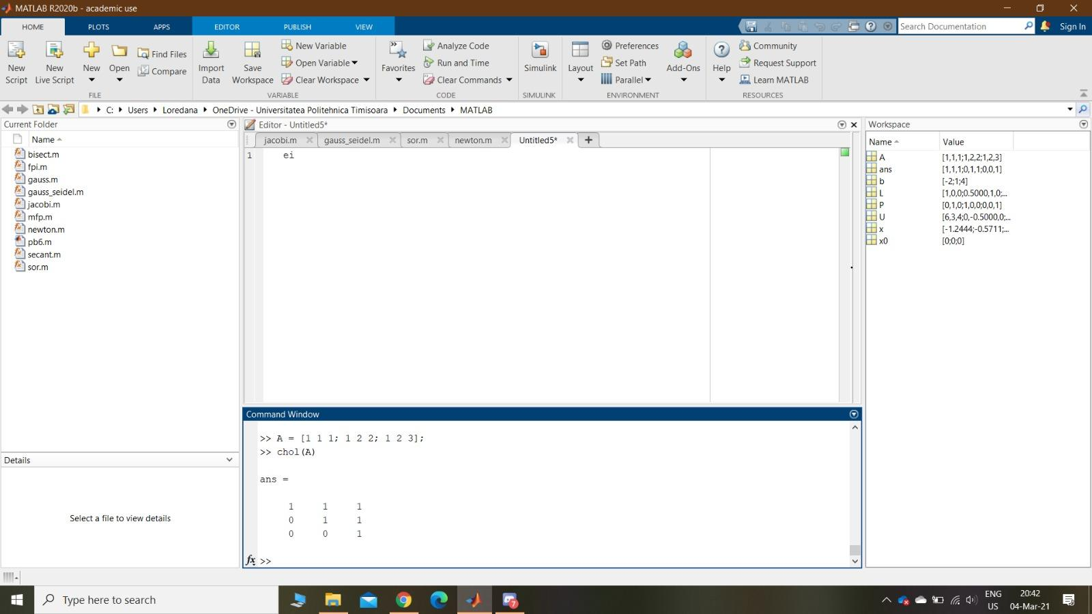

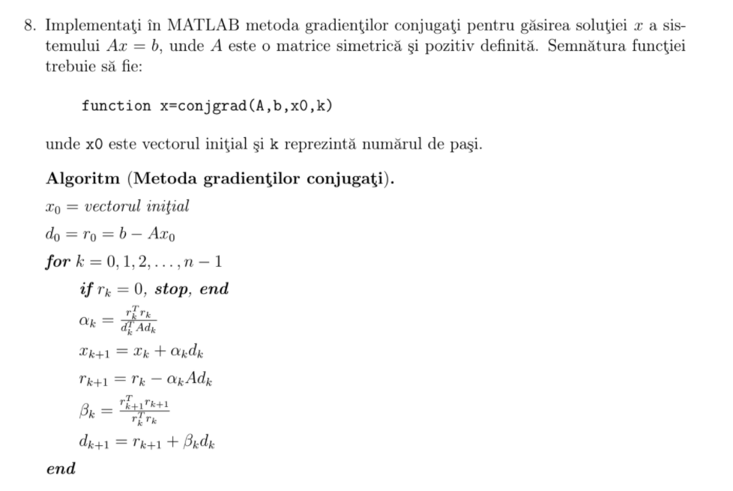

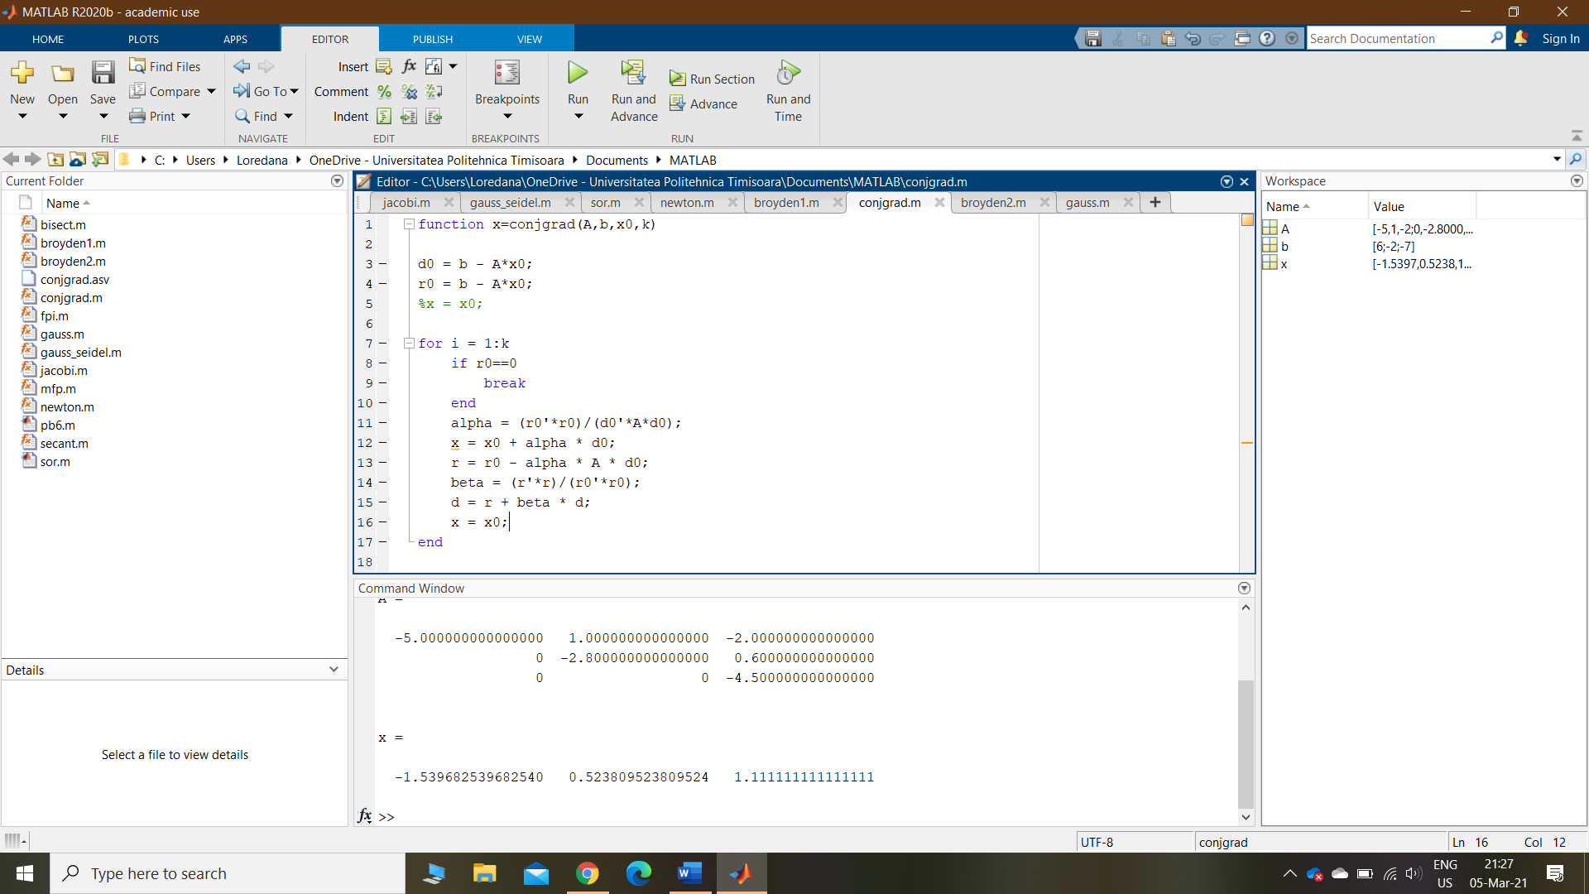

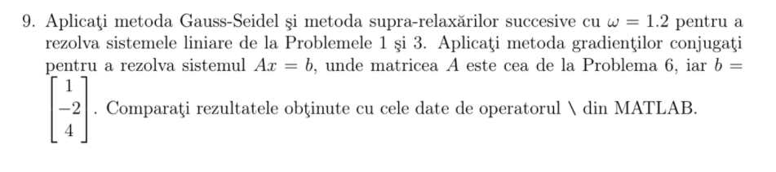

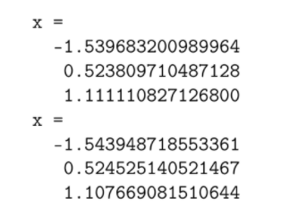

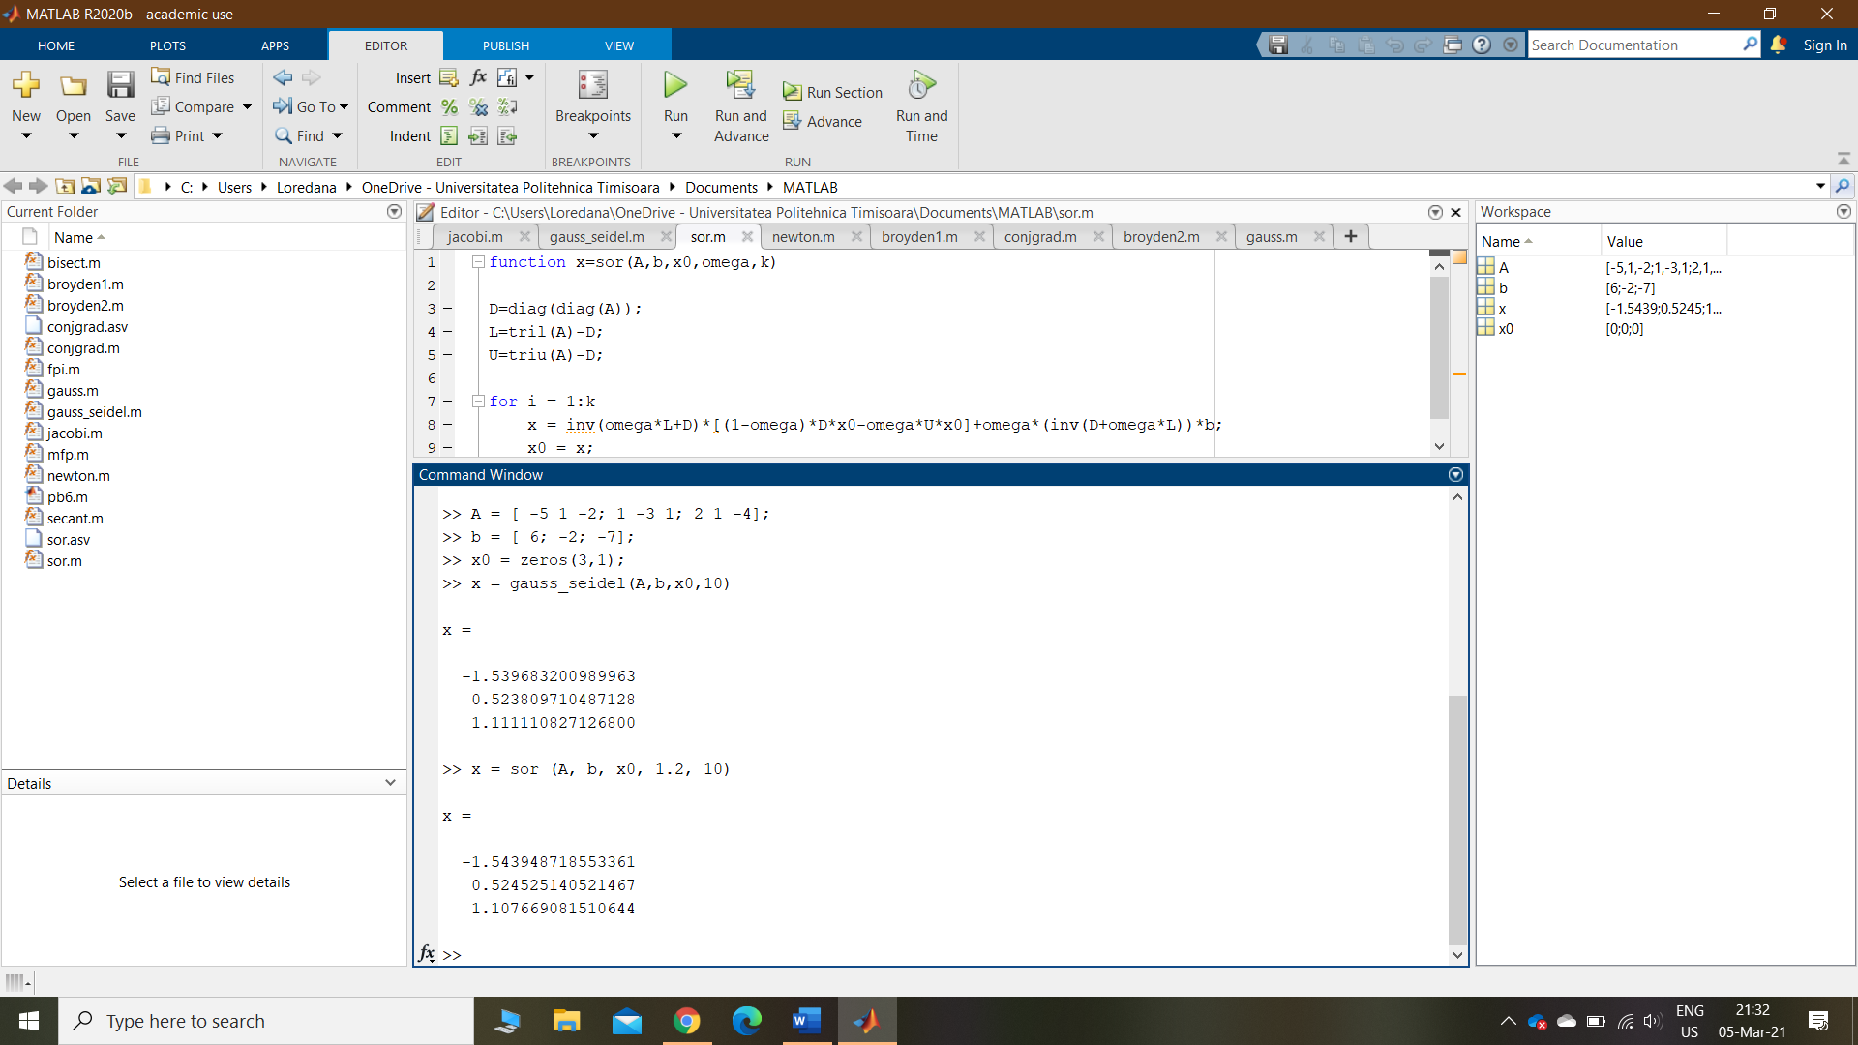

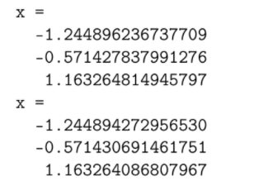

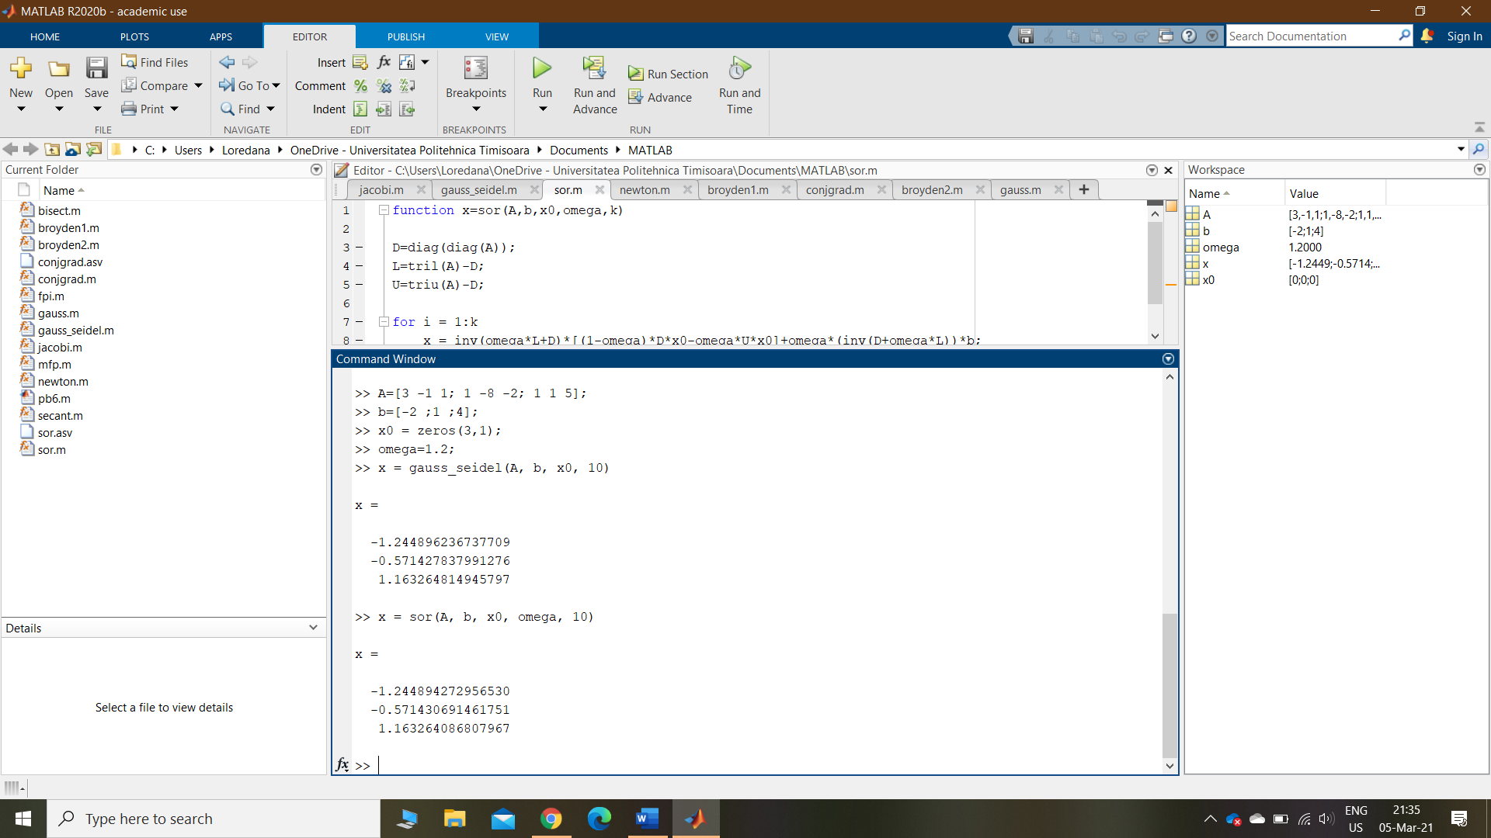

function x=conjgrad(A,b,x0,k)

d=b-A\*x0;

r=b-A\*x0;

x=x0;

for j=1:k

if r==0

break;

end

alpha=(r’\*r)/(d’\*A\*d);

x=x+alpha\*d;

r0=r;

r=r-alpha\*A\*d;

beta=(r’\*r)/(r0’\*r0);

d=r+beta\*d;

end

SAU

function x=conjgrad(A,b,x0,k)

d0 = b- A\*x0;

r0 = b- A\*x0;

for i =1:k

if r0==0

break;

alpha = (r0'\*r0) / (d0'\*A\*d0);

x=x0+ alpha \* d0;

r= r0- alpha\*A\*d0;

beta = (r'\*r)/(r0'\*r0);

d = r+ beta\* d0;

x0=x;

r0=r;

d0=d;

end

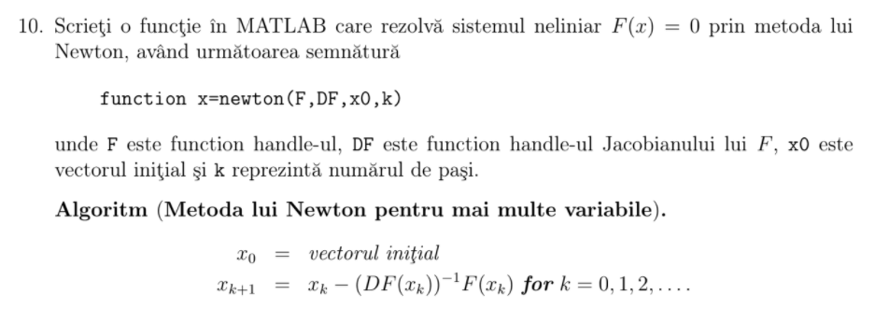

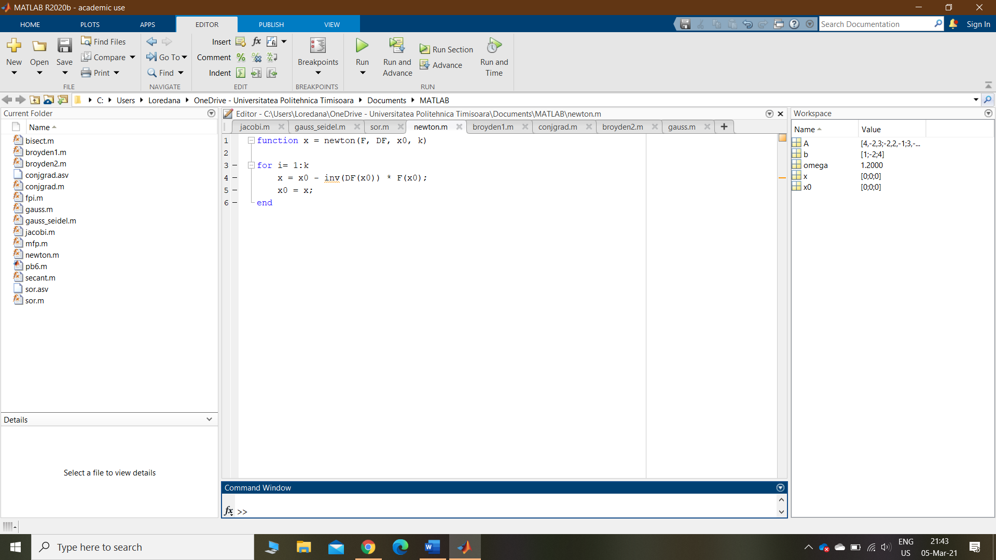

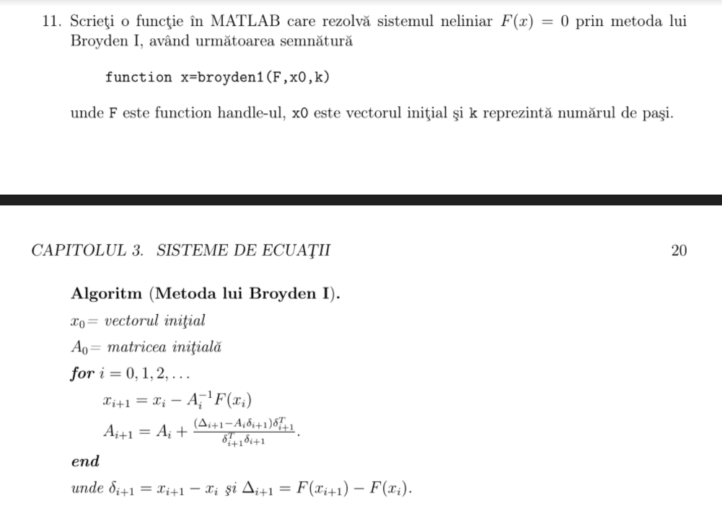

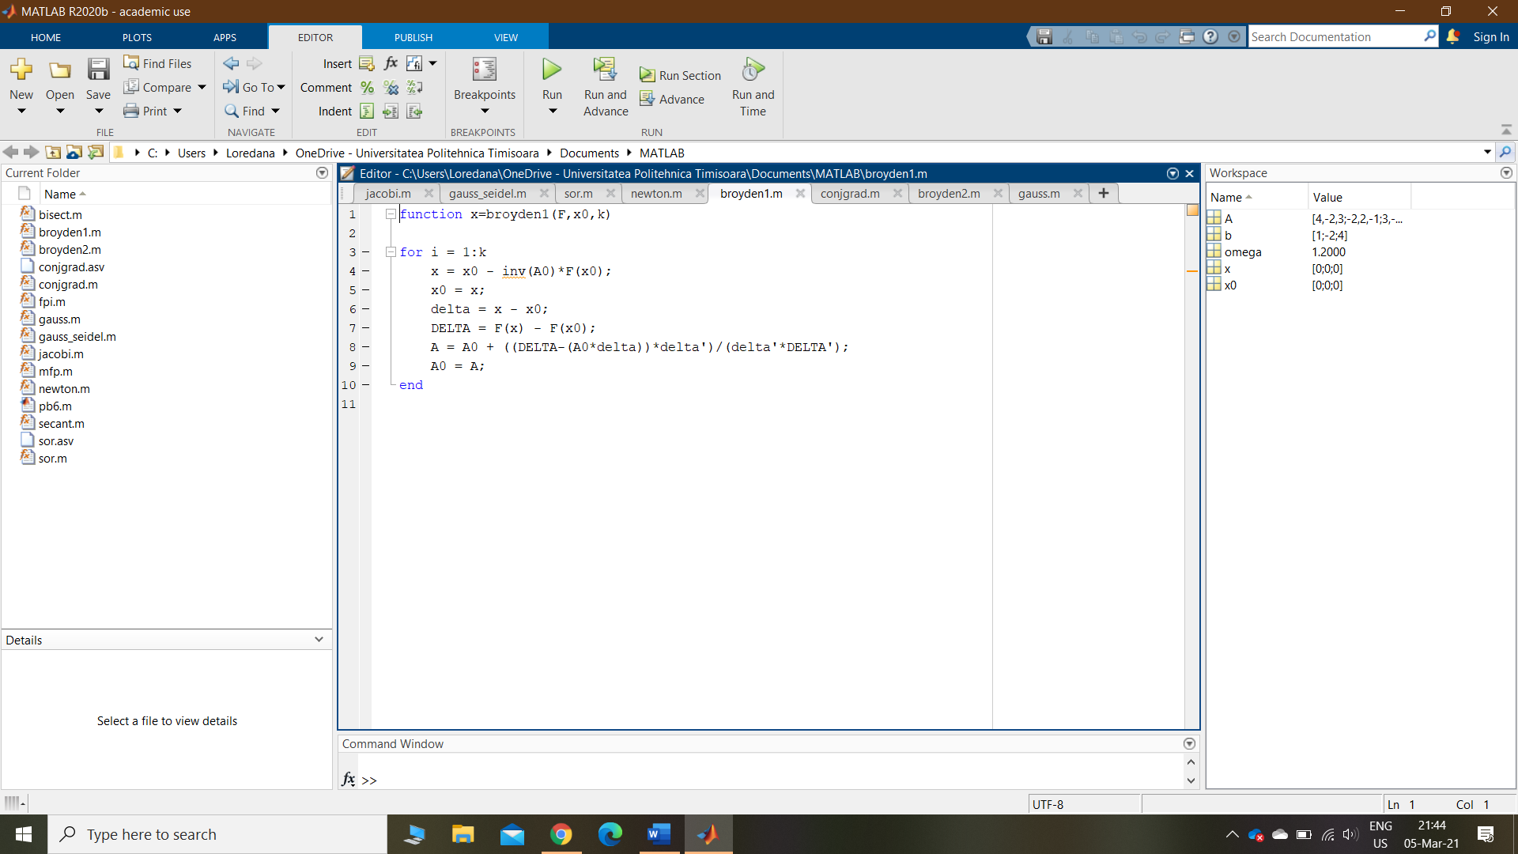

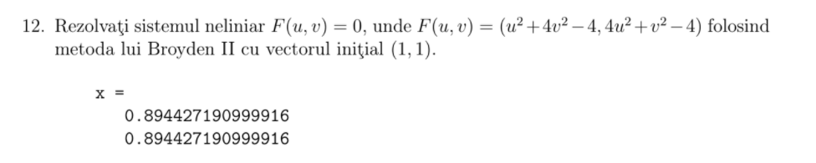

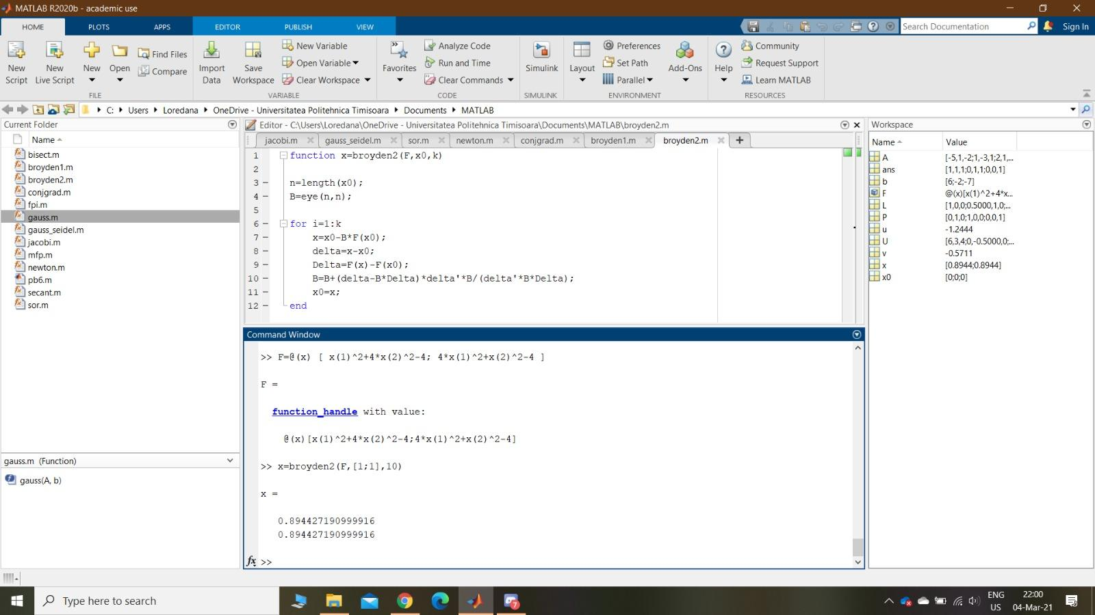

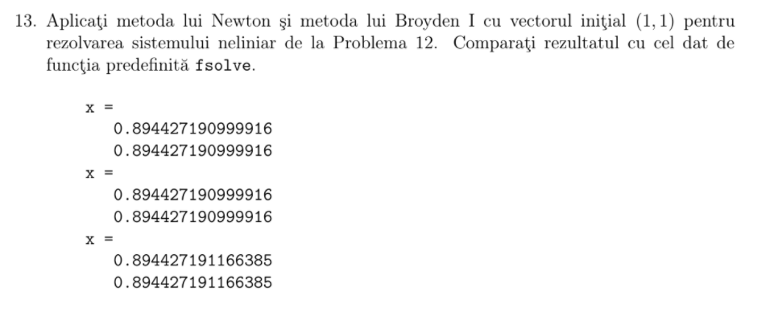

function x=broyden1(F,x0,k)

n=length(x0);

A=eye(n,n);

for i=1:k

x=x0-inv(A)\*F(x0);

delta=x-x0;

Delta=F(x)-F(x0);

A=A+(Delta-A\*delta)\*delta’/(delta’\*delta);

x0=x;

end